AI ASSISTANT LAB (9.4)
Name :ch srinidh rao
2303A52398
Batch 44

Task 1: Auto-Generating Function Documentation in a Shared
Codebase
Task Description
You are given a Python script containing multiple functions without any
docstrings.
Using an AI-assisted coding tool:
• Ask the AI to automatically generate Google-style function
docstrings for each function
• Each docstring should include:
o A brief description of the function
o Parameters with data types
o Return values
o At least one example usage (if applicable)
Experiment with different prompting styles (zero-shot or context-based)
to observe quality differences.
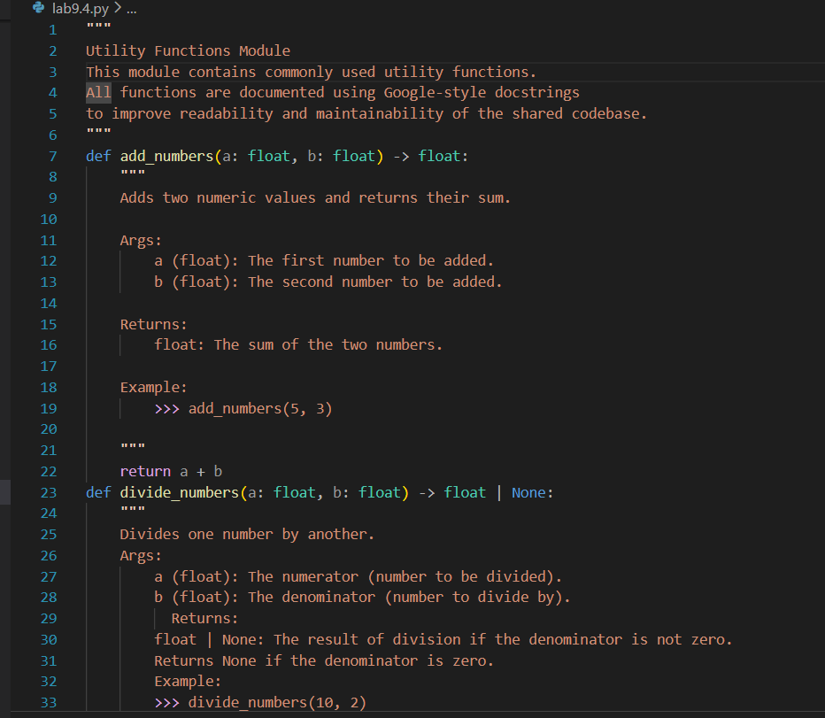
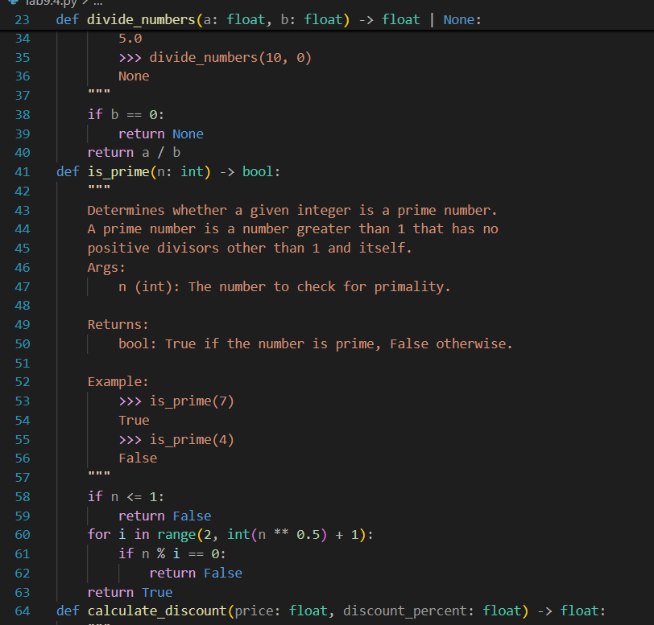
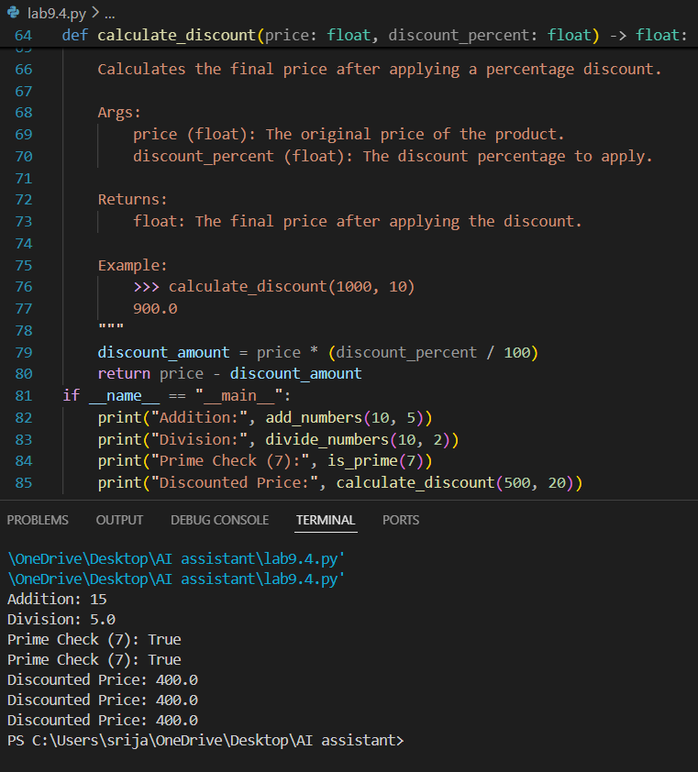
Observation:
- Zero-shot prompting produces correct but simpler documentation.
- Context-based prompting produces more professional and structured documentation.
- Adding role context (e.g., "senior developer") improves clarity and completeness.
- AI significantly reduces documentation effort and improves code readability.
- Task 2: Enhancing Readability Through AI-Generated Inline
- Comments
- Scenario
- A Python program contains complex logic that works correctly but is
- difficult to understand at first glance. Future maintainers may find it hard
- to debug or extend this code.
- Task Description
- You are provided with a Python script containing:
- • Loops
- • Conditional logic
- • Algorithms (such as Fibonacci sequence, sorting, or searching)
- Use AI assistance to:
- • Automatically insert inline comments only for complex or non-
- obvious logic
- • Avoid commenting on trivial or self-explanatory syntax
- The goal is to improve clarity without cluttering the code.
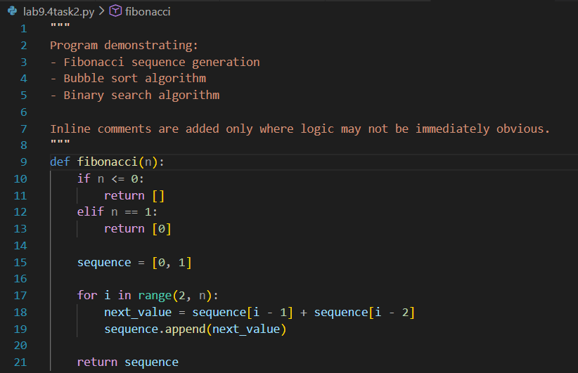
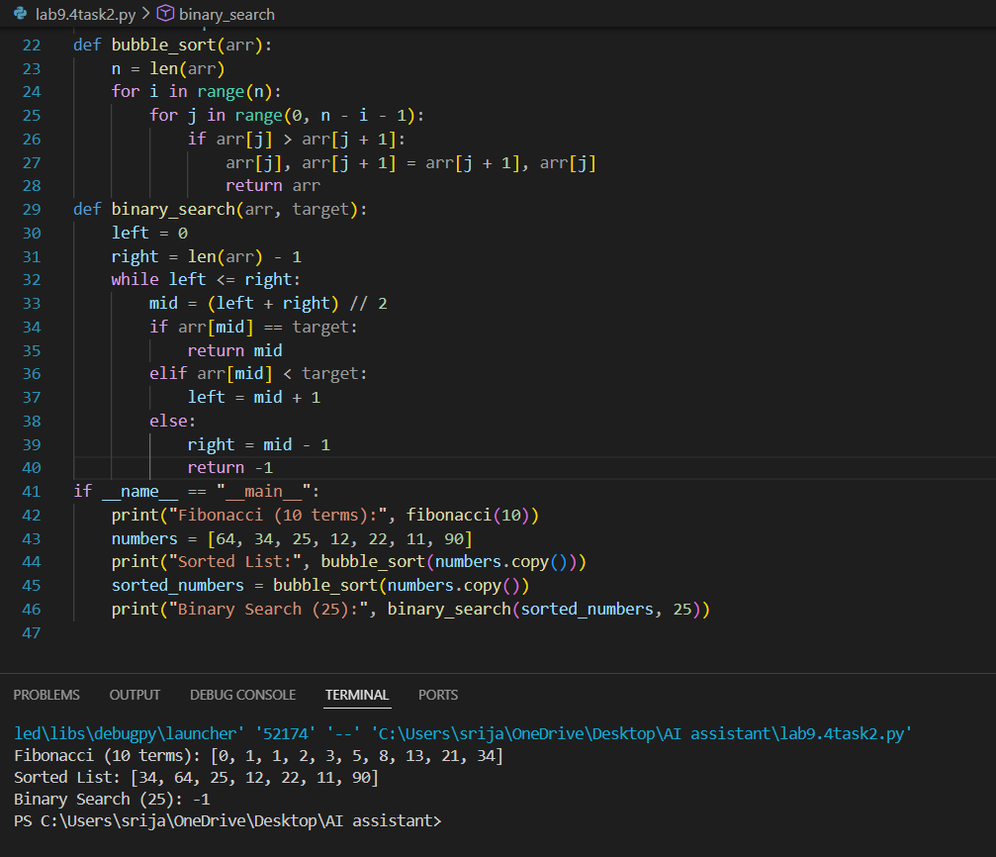
Observations :
After using AI assistance to generate inline comments, the following observations were made:
The AI correctly added comments to:
- The recurrence relation in the Fibonacci sequence
- The element-swapping mechanism in Bubble Sort
- The search space reduction logic in Binary Search
- Task 3: Generating Module-Level Documentation for a Python
- Package
- Scenario
- Your team is preparing a Python module to be shared internally (or
- uploaded to a repository). Anyone opening the file should immediately
- understand its purpose and structure.
- Task Description
- Provide a complete Python module to an AI tool and instruct it to
- automatically generate a module-level docstring at the top of the file
- that includes:
- • The purpose of the module
- • Required libraries or dependencies
- • A brief description of key functions and classes
- • A short example of how the module can be used
- Focus on clarity and professional tone
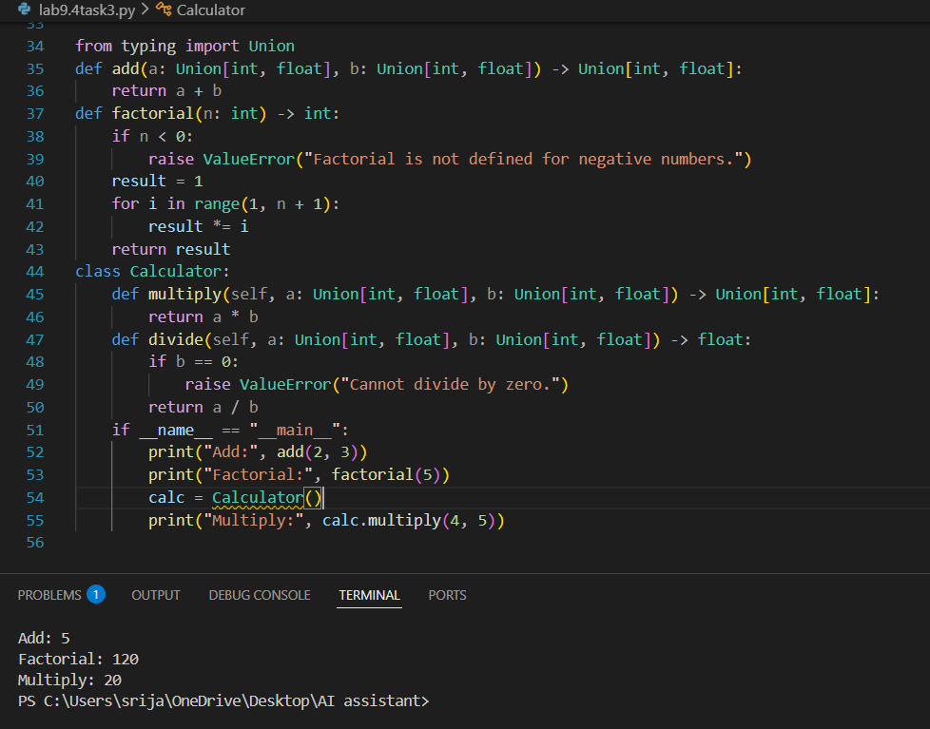
Observation:
n this task, AI was used to generate a professional module-level docstring for a Python package. The generated documentation clearly explained the purpose of the module, listed dependencies, described key functions and classes, and provided an example of usage. This improved code readability, maintainability, and usability. Overall, AI-assisted documentation helps save time and makes the module suitable for real-world projects and repositories.
Task 4: Converting Developer Comments into Structured Docstrings
Scenario
In a legacy project, developers have written long explanatory comments
inside functions instead of proper docstrings. The team now wants to
standardize documentation.
Task Description4
You are given a Python script where functions contain detailed inline
comments explaining their logic.
Use AI to:
• Automatically convert these comments into structured Google-
style or NumPy-style docstrings
• Preserve the original meaning and intent of the comments
• Remove redundant inline comments after conversion
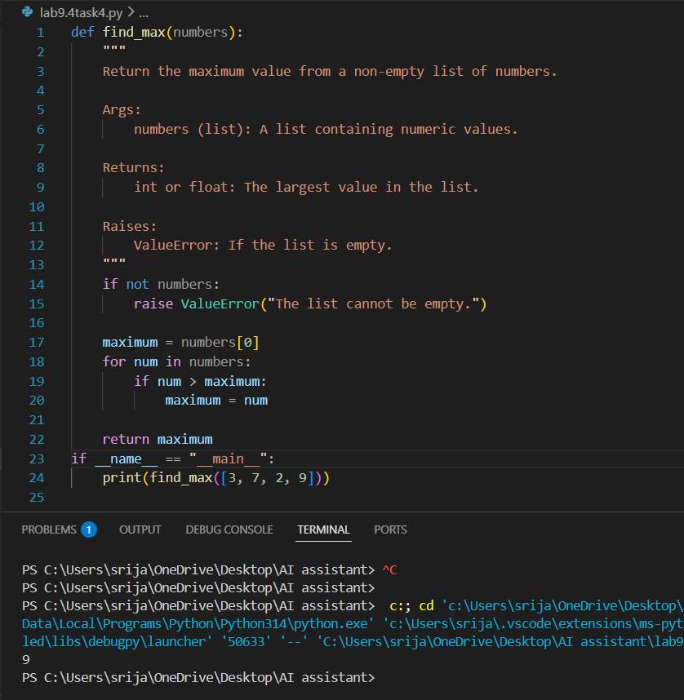
Observation:
In this task, the function was updated with a structured Google-style docstring while removing unnecessary explanatory comments inside the function body. The AI successfully preserved the original logic and intent of the code while improving documentation consistency. The function is now cleaner, easier to read, and follows standard documentation practices. This improves maintainability, reduces clutter, and ensures uniform documentation across the codebase.
Task 5: Building a Mini Automatic Documentation Generator
Scenario
Your team wants a simple internal tool that helps developers start
documenting new Python files quickly, without writing documentation
from scratch.
Task Description
Design a small Python utility that:
• Reads a given .py file
• Automatically detects:
o Functions
o Classes
• Inserts placeholder Google-style docstrings for each detected
function or class
AI tools may be used to assist in generating or refining this utility.
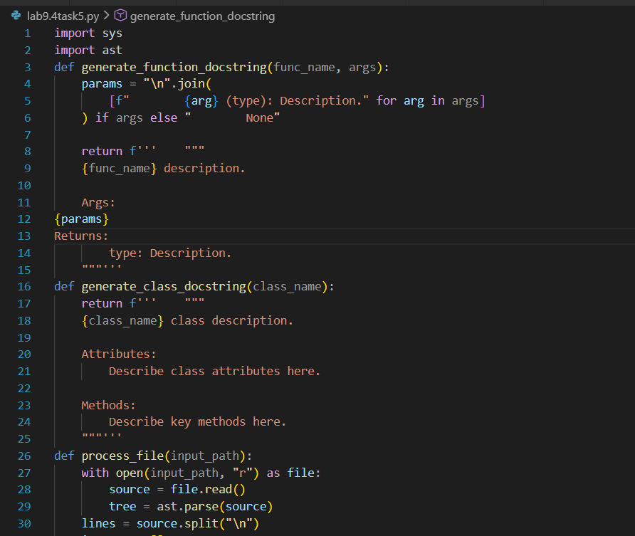
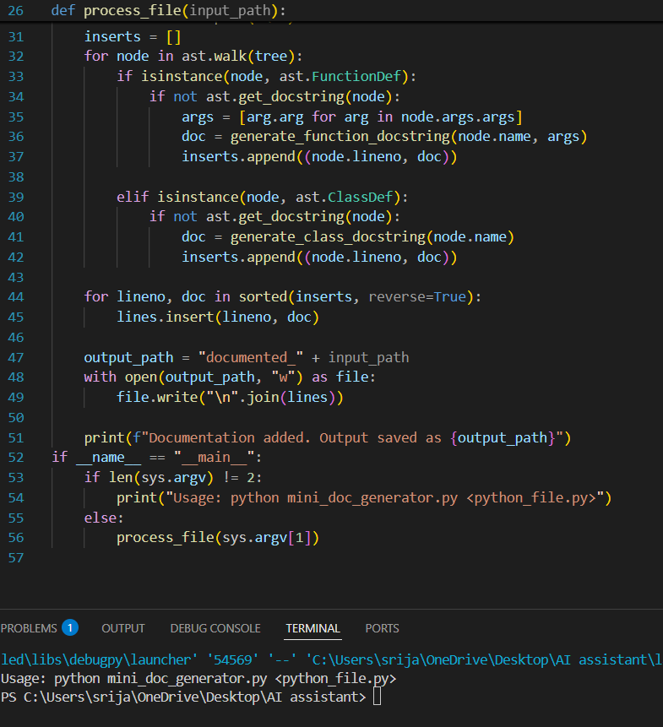
Observation:
In this task, a mini automatic documentation generator was developed to simplify the process of documenting Python files. The utility successfully reads a given .py file, detects functions and classes using the last module, and inserts placeholder Google-style docstrings where documentation is missing. The generated output maintains the original code structure while improving readability and encouraging standardized documentation practices. This tool reduces manual effort, promotes consistency across the codebase, and helps developers quickly start documenting new files. Overall, it demonstrates how automation can improve productivity and maintainability in software development

